Waste Steel Wire Aggregates in Paver Block: A Green Approach
Harsh Lakhmani¹, Divya Srivastava^{2*}
¹U.G. Student, Department of Civil Engineering, Amity University, Lucknow, 226020, India
²Assistant Professor, Department of Civil Engineering, Amity University, Lucknow, 226020, India
*Corresponding author: Divya Srivastava (Email ID:dsrivastava4@lko.amity.edu)
Abstract: Nowadays, the paving blocks in the market are costly. This study introduces a new type of paving block that is more affordable than conventional paving blocks. The new paving blocks are made from waste materials such as steel bearing balls, wires, lath scrap, and quarry dust, which makes them more environmentally friendly. In this study, the compressive strength eco-friendly paver block is compared to the conventional paving block. For manufacturing of paver block, bearing balls and wires have been used as coarse aggregate, while quarry dust has been used as fine aggregate. This paper presents a parametric experimental study on the production of paving blocks using waste steel wire aggregates in the form of steel wires cut to a length of 20-22 cm and rounded bearings of 6.35 mm. To investigate the increase in compressive strength, various percentages of waste steel wire aggregates are added to the concrete of paving blocks. The results of the tests revealed that integrating various percentages of wasted steel wire aggregates with paving blocks can increase impact strength by up to 50% when compared to standard paving blocks.
Keywords - Waste Steel Aggregates, Compressive Strength, Concrete Interlocking Paving Blocks, Round Bearings
- INTRODUCTION
Concrete block paving has been widely used nowadays because of its diverse advantages. It is forms in rectangular shape accordance to bricks shape and now there are many various shapes of paving blocks. These blocks are a type of concrete with good in quality and durability due to the manufacturing and the right method of mixture [1]. The concrete paving blocks also something interesting and versatile because of its great resilience, its strength in accommodate traffic flow, interesting aesthetic, and function, cost effective and do not need to be maintenance if the correct way installations from first phase [2,3].The material that use for paving blocks has been widely changed where there are many of paving blocks are added or replaced with the used materials or wastes materials to reduce environmental pollutions besides can improve its strength and also their mechanical properties[4,5,6]. From the literature study, there are many researchers use waste materials as the aggregate and cement replacement to create paving blocks.
Numerous research have been conducted in the recent literature to study the usage of waste materials as partial replacements in paving blocks The thorough literature study establishes a solid foundation for current research on the performance of paver block when partially replaced with materials such as cement, sand, or coarse aggregate[7,8,9,10]. The materials used are waste steel, rounded bearings, lath scrape, cut size bars, etc. which these materials are available in cheaper price or free of charge[11,12,13]. The primary goal of this research is to look at the performance and properties of paver blocks constructed from various waste components and compared the results with conventional paver block

2. MATERIAL & METHODOLOGY
The scope of these study is to test the strength of eco-friendly paving block that use waste materials (wires and bearings) as an additive in coarse aggregate with coarse gravel and materials (dust) as fine aggregates in concrete mixture and will be compared to control paving blocks.
2.1 Materials
We will be producing concrete paver block using waste steel wire aggregate in this paper. The materials used in this study are follows:
2.1.1 Cement
For concrete work ordinary Portland cement is used which this type of binder has two important properties, which is good in adhesion and cohesion with these features, cement will act as a binder to bind the aggregate to form a strong concrete mix.
2.1.2 Water
Water used for mixing concrete and curing must be free of hazardous materials. In general, the minimal water/cement ratio employed for hydration is 0.3 to 0.8. Excess water in the concrete mixture can make the bonding between the concrete less effective and cause holes to emerge in the concrete mixture. In this study, concrete mixture ratio is 1:2:4 (cement: sand: stone fragments) with a water/cement ratio 0.60
2.1.3 Aggregates
The two kinds of fine aggregate used, which is sand and quarry dust. Sand is used for control paving blocks while quarry dust is used for eco-friendly paving block. Fine aggregate that used are passing the sieve analysis test at size 2.36mm. For coarse aggregate, control paving blocks used coarse gravel while eco-friendly paving block use 75% of gravel stone and 25% of waste material (wires, steel ball bearings, lath scrape, crushed can pieces). The coarse gravel used are passing 20mm in size of sieve analysis test.
2.1.4 Steel Wire
The waste materials used are steel wirers, round bearings, lath scrape (Karadi) which is a by product of cutting and filing job. Bearings balls are the waste break or dispose bearings. They are completely garbage and are used for land filling, dumping, or melting, which requires a great amount of energy and emits hazardous gases or increases the carbon footprint. Using this waste materials in construction is a win-win solution. It helps to reduce pollution and conserve resources, while also producing high-quality products. Fig. 1 shows the steel wire which is used in the present study. The used materials are cut to the needed sizes. steel wires cut size of length 20cm – 22cm rounded bearings of size 6.35 mm.
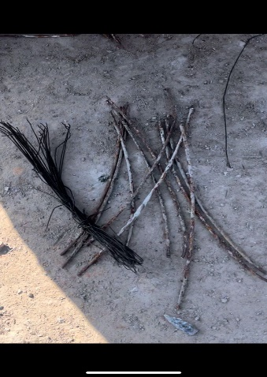
Fig 1 Steel Wire Waste
2.2 Methodology
First step from the procedure are making 12 moulds with size 240 mm x 120 mm x 80 mm (Figure 2). Then, fine and coarse aggregate will be test by sieve analysis test to get the size needed. After that, the concrete work will be done and proceed with the tests. First test are slump test where the result should not exceed or less then 75mm (±25mm), to achieve the real slump and workability. Then it will be cube test and curing process to proceed with density test where the mass (kg) of paving blocks will be divided by the volume (m³) and compressive strength test where the compressive result will get when load (kN) at the failure divided by the area of the surface paving block (m²) when achieve 7 and 14 days.
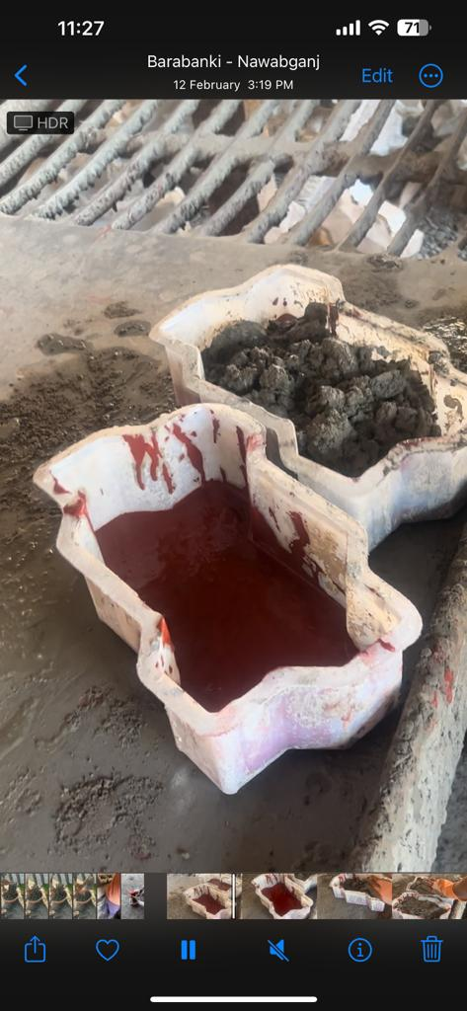
Fig 2 Paving Block Specimen
There are 12 paving blocks produced where 6 of it are control paving blocks and the balance is Eco-Friendly Paving Block. The test will be done when the paving block reaches the 7 and 14 days of their mature age and the result of Eco-Friendly Paving Block will be compared to the control paving blocks based on the test performed.

2.2.1 Design and classification of paver block
Normally, Paving blocks are rectangular-shaped and it is almost like a brick. But now, there is a lot paving blocks variation. According to the study in this paper, the classification for paving blocks is based on SNI 03-0691-1996 (zigzag type sizes 240 mm x 120 mm x 80 mm) and Table 1 show the classification of the paving blocks based on their compressive strength.
Table 1 Classification of Paver Blocks
Grade | Classification | Compressive strength (MPa)
A | Road, Petrol Pump | 45 | 35
B | Parking | 30 | 17
C | Walkway | 20 | 15
D | Play Area Or Garden | 10 | 7.5

3. RESULTS & DISCUSSION
Compressive strength test measured the maximum amount of compressive load a material can bear before fracturing the test piece, usually in the form of a cube, prism, or cylinder, is compressed between the platens of a compression-testing machine by a gradually applied load. The zigzag shaped tile with area 32760 (240x120x80mm) which is tested under a compressive testing machine of 10kn-300kn as shown in Fig. 3
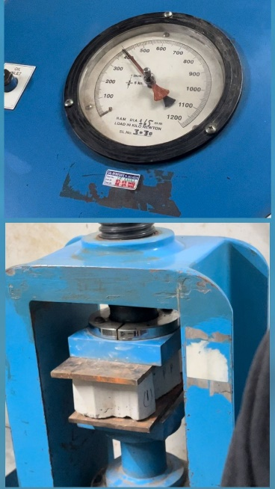
Fig 3. Compressive Test of Paver Block (ZigZag)
To work on control paving block the ratio of materials used cement: sand: coarse gravel is case1 cement 625gm: sand 2667gm: coarse gravel 1775gm (1:4:2.6) (as per standard IS:15658:2006) and for eco-friendly tiles the ratio of materials used case 2 cement 625gm: sand 2667gm: waste 150gm: coarse gravel 1775gm (1:4.2:0.2:2.9) whose strength goes upto 29.59N/mm², then under case 3 cement 625gm: sand 2667gm: waste 300gm: coarse gravel 1775gm (1:4.2:0.4:2.8) strength goes up to 32.67N/mm² then under case 4 cement 625gm: sand 2667gm: waste 750gm: coarse gravel 1775gm (1:4.2:1.1:2.8) strength goes up to 34.54N/mm² and case 5 cement 625gm: sand 2667gm: waste 875gm: coarse gravel 1775gm (1:4:1.4:2.8) strength goes up to 43.57N/mm² which is representing (cement: sand: waste material: coarse aggregate) Volume of 0.032m³ concrete mixtures are made for 32 moulds based on the ratio. Table 3 shows the quantity of material that used for both types of paving blocks.
Table 2 Quantity of Material
Paving blocks | Cement | Fine aggregate | Eco friendly material | Couse aggregate
- Case.1  - Standard (1:4:2.6) | 13.3% | 52.63% | 0% | 34.9%
- Case 2  (1:4.2:0.2:2.9) | 11.9% | 51.1% | 2.8% | 34%
- Case 3  (1:4.2:0.4:2.8) | 11.6% | 49.6% | 5.5% | 33%
- Case 4  (1:4.2:1.1:2.8) | 10.7% | 45.8% | 12.8% | 30.5%
- Case 5  (1:4.2:1.4:2.8) | 10.5% | 44.8% | 14.7% | 29.8%

Based on the result and analysis the table 3 is showing the compression of strength with standard tile and the eco-friendly tile and increased strength percentage.

Table 3. Compressive strength results
Paving block | Composition | Standard Strength | Waste strength
Case1 | 1:4:2.6 | 19.25 N/mm² | -
Case2 | 1:4.2:0.2:2.9 | 19.25 N/mm² | 29.59 N/mm²
Case3 | 1:4.2:0.4:2.8 | 19.25 N /mm² | 32.67 N/mm²
Case4 | 1:4.2:1.1:2.8 | 19.25 N/mm² | 34.54 N/mm2
Case5 | 1:4.2:1.4:2.8 | 19.25 N/mm² | 43.57 N/mm²

The comparison of compressive strength of paver block using waste material with traditional block is shown in Fig. 4.
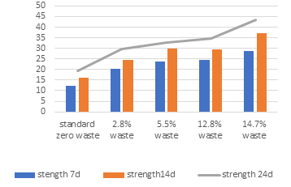
Fig. 4 Effect of eco-friendly paver block on Compressive strength (N/mm²)
Steel aggregates can improve the mechanical property such as elastic modulus, stresses, and optimum compressive strength can be achieved with use of waste aggregate % 2.8, 5.5, 12.8, 14.7, can raise compressive strength up to 53%, 69.7%, 79.4%, 126%, respectively, of ordinary paver block zigzag type these waste products are added in various percentages in concrete prepared with standard design ratio. It is used to reduce the cost of paving block manufacturing and it is used in different proportion with other material such as coarse aggregate, fine aggregate, cement. Waste such as cans of soft drink, lath machinery scrape, wires, steel bars, which are available from variety of sources, wires and bars are cut longitudinally in the desired size according to the moulds which is zigzag shape and cleaned using water, then being dried then being scratch by the iron brush so that the bond between steel bars and concrete became stronger.
Cost analysis: The normal standard M40 tile cost of production is Rs.16.24 in this experiment we are using waste to increase strength and to reduce cost so the tile of 5th sample shown in table3 with 875gm of waste achieve strength of 43n/mm2 which cost around Rs.12.74. So we are saving around Rs.3.5 per pcs of eco-friendly tiles.

4. CONCLUSITION
The main conclusions drawn from the studies so far using waste material for the manufacturing of paver block may be summarised as follows:
1. The workability of standard paving blocks are better than eco-friendly paving block using steel wire aggregate.
2. For density, eco-friendly paving block result better than standard paving block.
3. This also can protect our environment from the waste material that can ruin the ecosystem. 4. Eco-Friendly Paving Block also cheaper because the used of waste material in the mixture the advantage is for the manufacturers and for the consumers that it will be cost effective and for the manufacturers there will be good profit margin.
5. Compressive strength of paver blocks zigzag shape using steel aggregates is much greater than that of paver block without steel aggregate.

REFERENCE
[1].A.A. Sharba, The efficiency of steel slag and recycled concrete aggregate on the strength properties of concrete, KSCE J. Civ. Eng. 23 (11) (2019) 4846– 4851.
[2]. A. Pappua, M. Saxenaa, S.R. Asolekarb, Solid wastes generation in India and their recycling potential in building materials, J Build Environ 42 (2007) (2007) 2311–2320.
[3]. K. Murari, R. Siddique, K.K. Jain, Use of waste copper slag, a sustainable material, J Mater Cycles Waste Manag. 17 (2015) 13–26, doi:http://dx.doi.org/ 10.1007/s10163-014-0254-x.
[4]. H. Qasrawi, F. Shalabi, I. Asi, Use of low CaO unprocessed steel slag in concrete as fine aggregate, Constr. Build. Mater. 23 (2) (2009) 1118–1125.
[5]. X. Yu, Z. Tao, T. Song, Z. Pan, Performance of concrete made with steel slag and waste glass, Constr. Build. Mater. 114 (2016) 737–746.
[6]. P.O. Awoyera, O.M. Olofinnade, A.A. Busari, I.I. Akinwumi, M. Oyefesobi, M. Ikemefuna, Performance of steel slag aggregate concrete with varied watercement ratio, J. Teknologi (Sciences & Engineering) 78 (10) (2016) 125–131.
[7]. I. Akinwumi, J. Adeyeri, O. Ejohwomu, Effects of steel slag addition on the plasticity, strength, and permeability of lateritic soil, ICSDEC 2012 (2012) 457–464.
[8]. K.A. Olonade, M.B. Kadiri, P.O. Aderemi, Performance of steel slag as fine aggregate in structural concrete, Niger. J. Technol. 34 (3) (2015) 452–458.

[9]. Yi Jiang, Tung-Chai Ling, Caijun Shi, Shu-Yuan Pan, Characteristics of steel slags and their use in cement and concrete—a review, Resources, Conserv. Recycl. 136 (2018) 187–197.
[10]. M. Maslehuddin, A.M. Sharif, M. Shameem, M. Ibrahim, M.S. Barry, Comparison of properties of steel slag and crushed limestone aggregate concretes, Constr. Build. Mater. 17 (2) (2003) 105–112.
[11]. T.S. Zhang, F.T. Liu, S.Q. Liu, Z.H. Zhou, X. Cheng, Factors influencing the properties of a steel slag composite cement, Adv. Cem. Res. 20 (4) (2008) 145– 150.
[12]. U. Bagampadde, H.I.A. Wahhab, S.A. Aiban, Optimization of steel slag aggregates for bituminous mixes in Saudi Arabia, J. Mater. Civ. Eng. 11 (1999) 30– 35.

[13]. S. Sorlini, A. Sanzeni, L. Rondi, Reuse of steel slag in bituminous paving mixtures, J. Hazadous Mater. 209-210 (2012) 84–91.

